**OECD COUNTRIES**

Dependent variable - Tradeinservices

Command- ls tradeinservices globalgovern distance fdiflow mtrij inequality summationofgdp comlang colbysamepower btrijt taxpaid

Result-

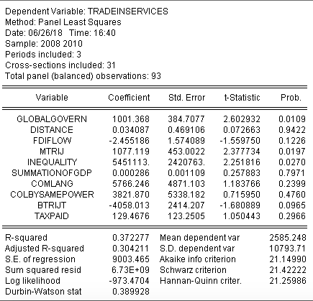

Dependent variable- fdi flow of stock

Command- ls fdiflow globalgovern distance tradeinservices mtrij inequality summationofgdp comlang colbysamepower btrijt taxpaid

Result-

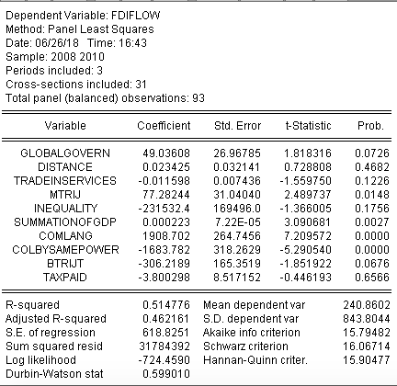

**BIMSTEC COUNTRIES**

Dependent variable- trade in services

Command- ls tradeinservices summationofgdp fdiflow comborder comlang colbysame btrijt mtrij inequality distance taxpaid globalgovern

Result

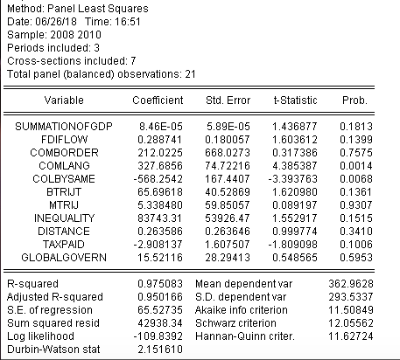

Dependent variable- fdiflow

Command- ls fdiflow summationofgdp tradeinservices comborder comlang colbysame btrijt mtrij inequality distance taxpaid globalgovern

Result-

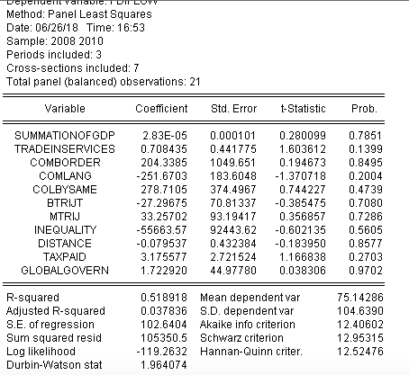

**COMPILED**

Dependent variable- trade in services

Command- ls tradeinservices summationofgdp fdiflow comlang colbysame btrijt mtrij inequality distance taxpaid globalgovern

Result-

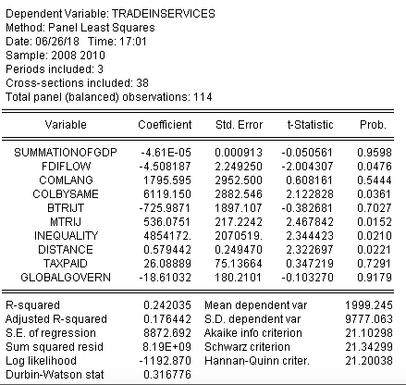

Dependent variable- fdiflow

Command- ls fdiflow summationofgdp tradeinservices comlang colbysame btrijt mtrij inequality distance taxpaid globalgovern

